Machine Description | Double-Trouble is a Linux boot-to-root VM featuring two independent vulnerable web applications. Each application provides a separate foothold vector. The machine teaches multi-vector exploitation, weak credentials, command-execution flaws, and privilege escalation through insecure SUID binaries.
Target IP | 10.173.255.121
Vulnerability Name | Unauthenticated Command Injection in Web Application  Local Privilege Escalation via Misconfigured SUID Binary
Service / Version | TCP / 80 HTTP
CVSS Score / Severity | 9.8 Critical
Attack Vector | AV:N/AC:L/PR:N/UI:N/S:U/C:H/I:H/A:H
Proof of Concept | STEP 1 – Discover the target IP using Net discover  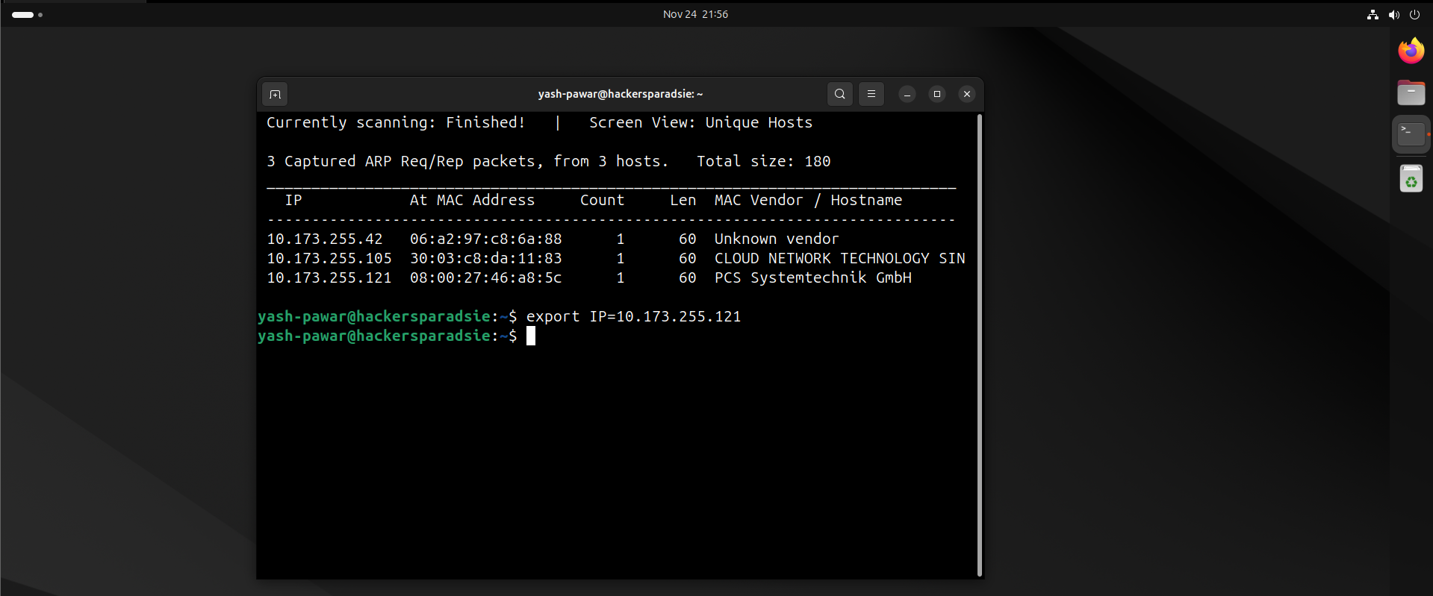  STEP 2 – Scan the target for Open ports using Nmap  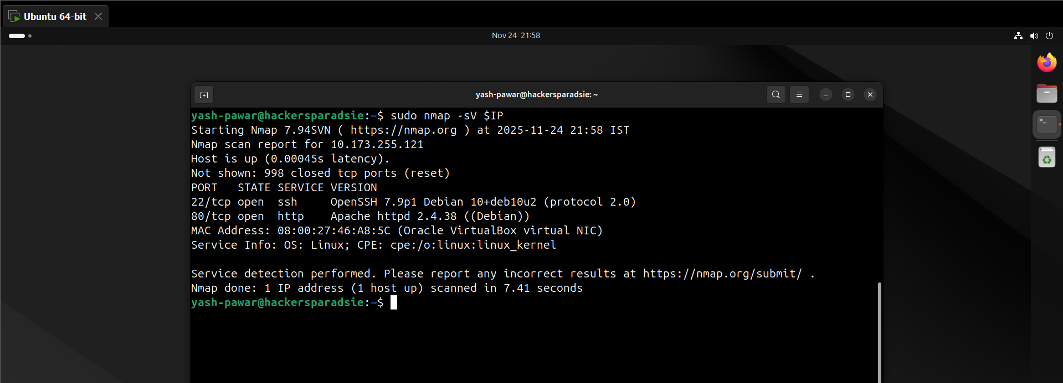  STEP 3 – Here we have Some Http portal on server on target machine  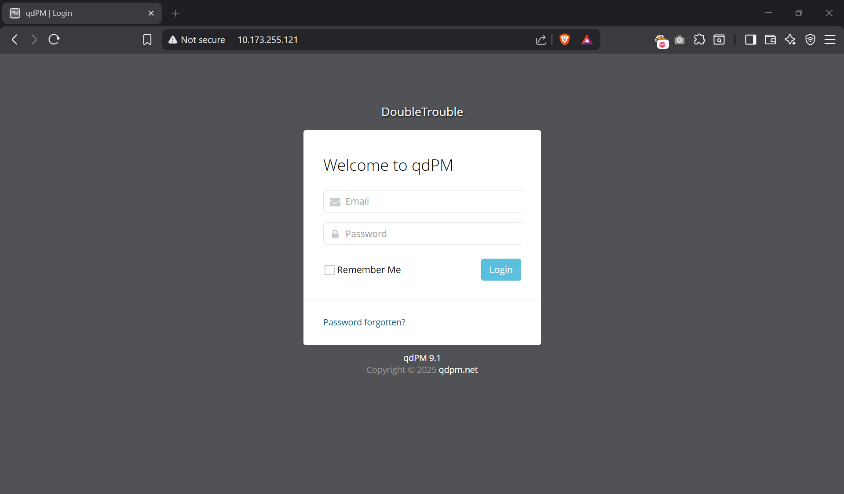  - Discover the Files on webserver  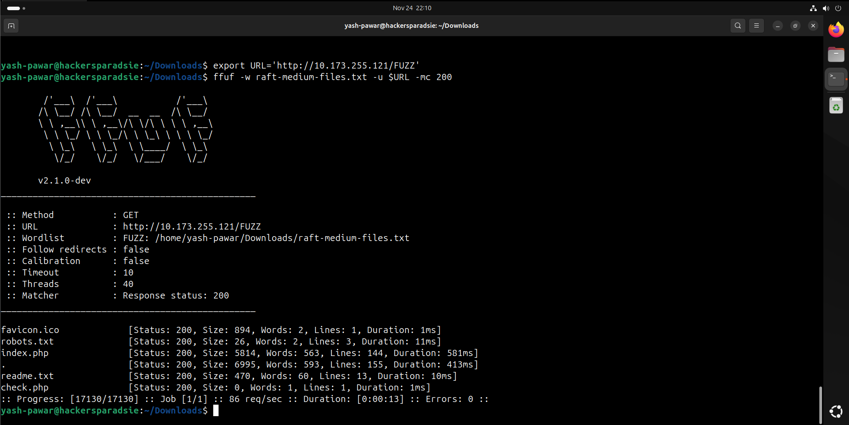  - Discover the Directories on webserver  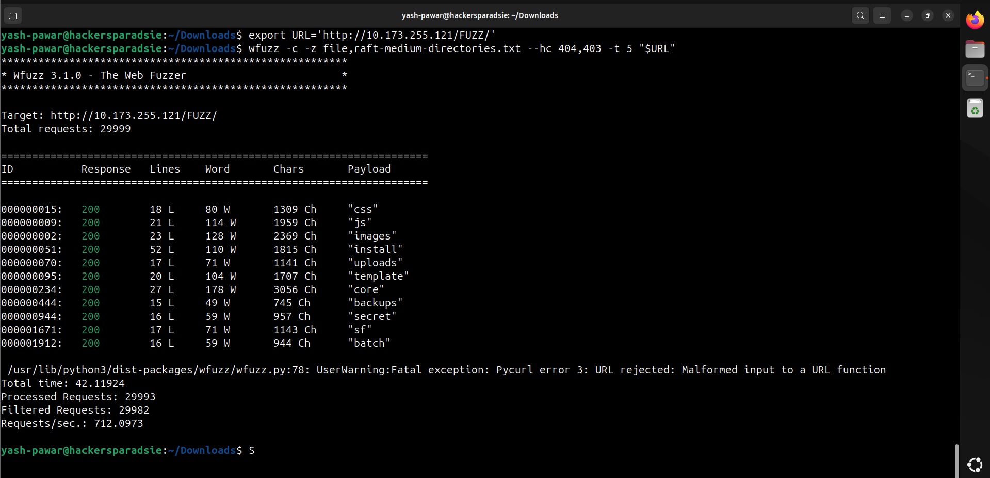  - Nothing on /robots.txt here  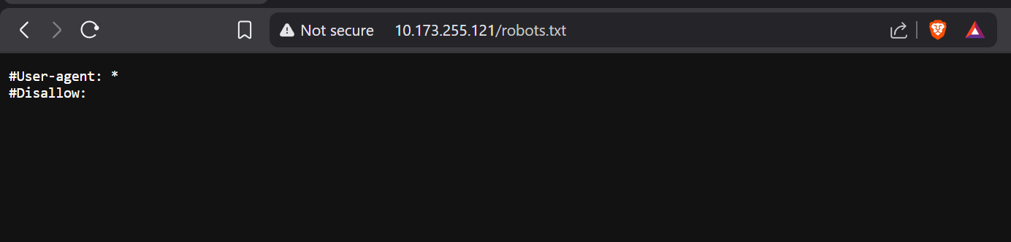  - We have Secret here  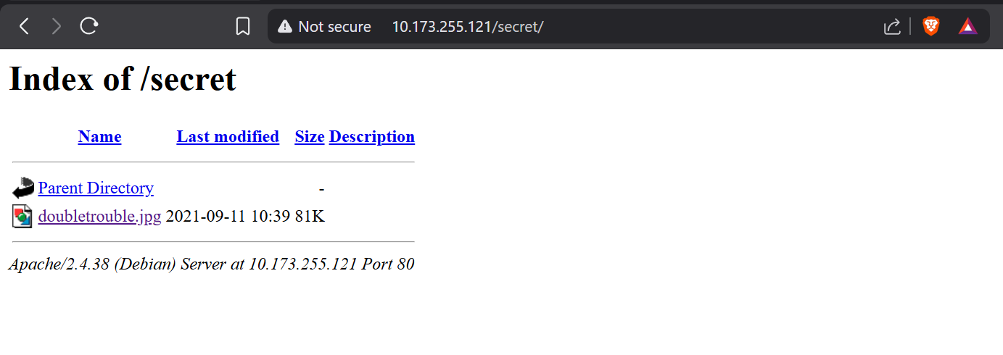  STEP 4 – Let’s Download file form here and Investigate for some hidden details  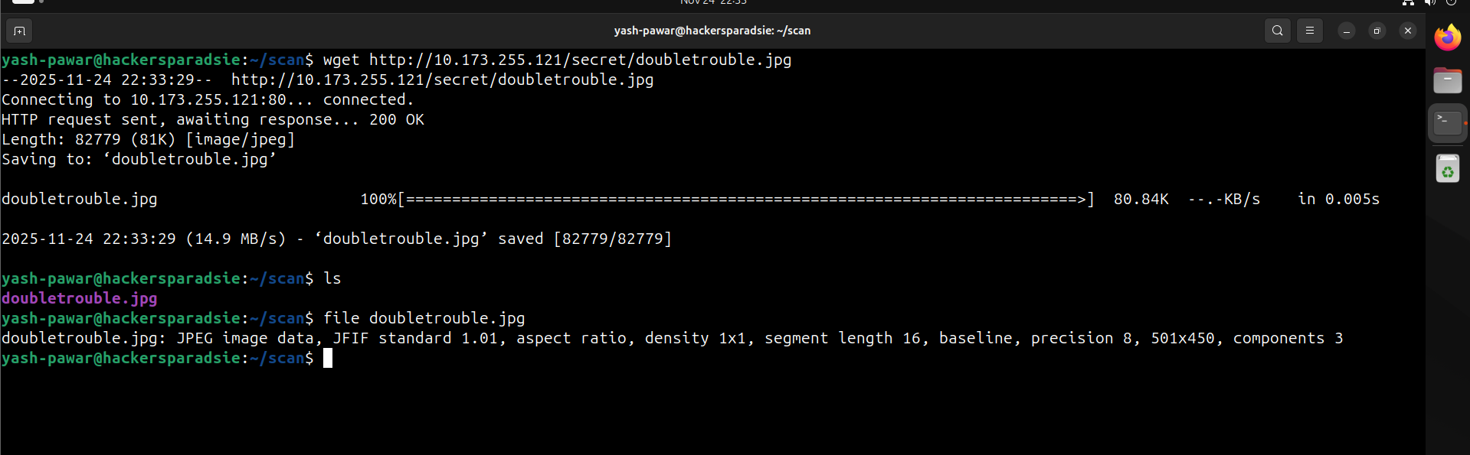  - Got extracted data  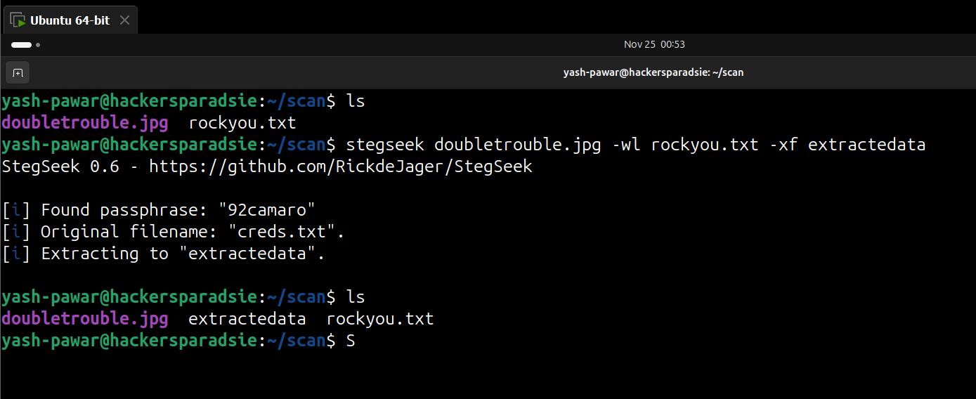  - Found Valid Creds  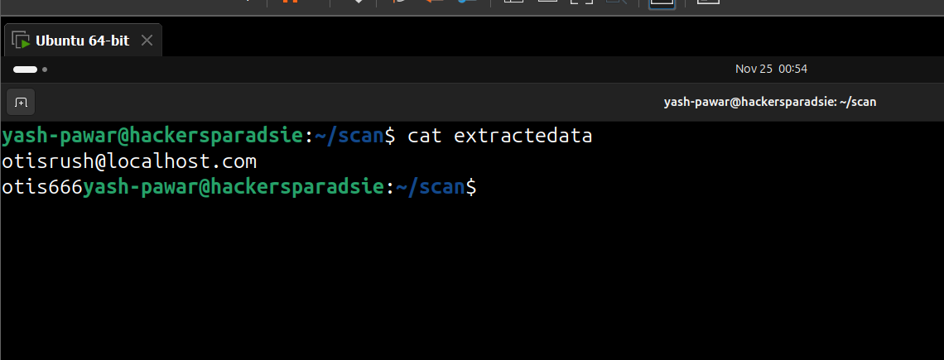  STEP 5 – Let’s try to authenticate to the login portal  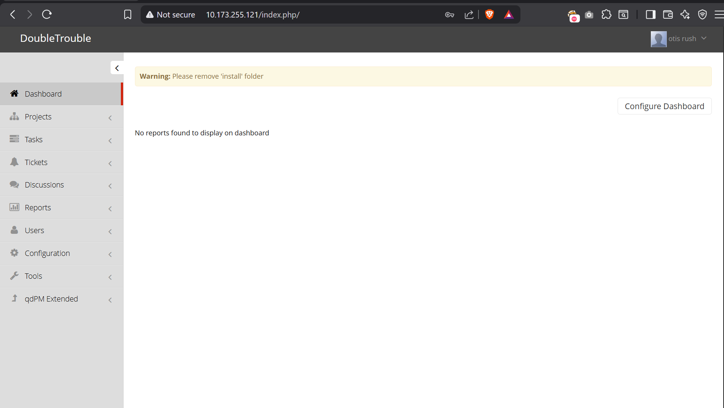  STEP 6 –PHP reverse shell upload and get connection on net cat  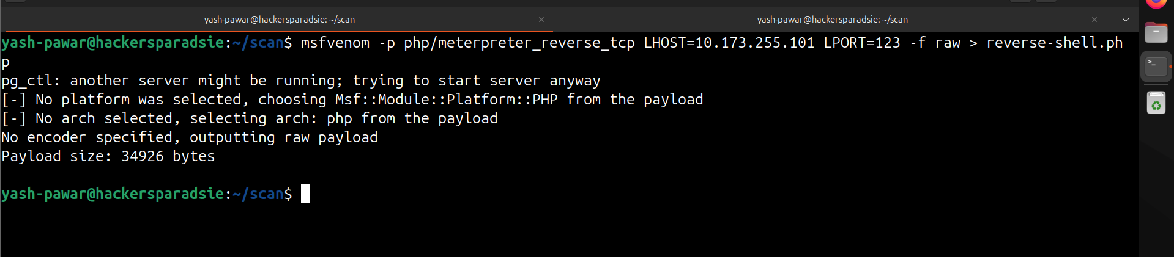  - Upload the shell  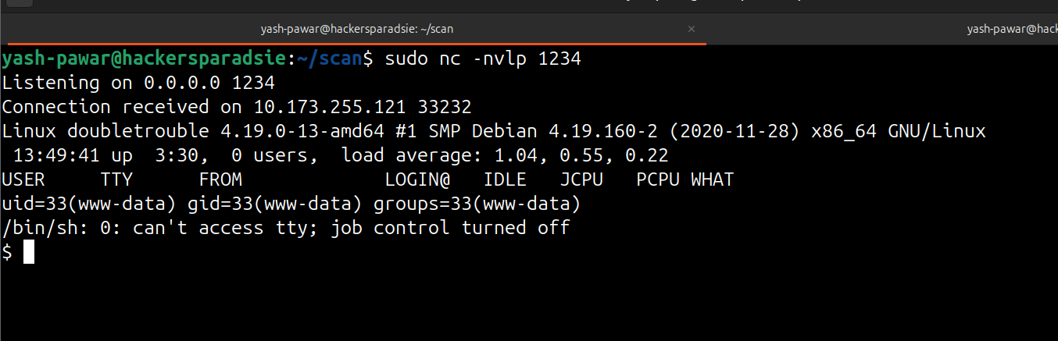  STEP 7 – Privilege Escalation  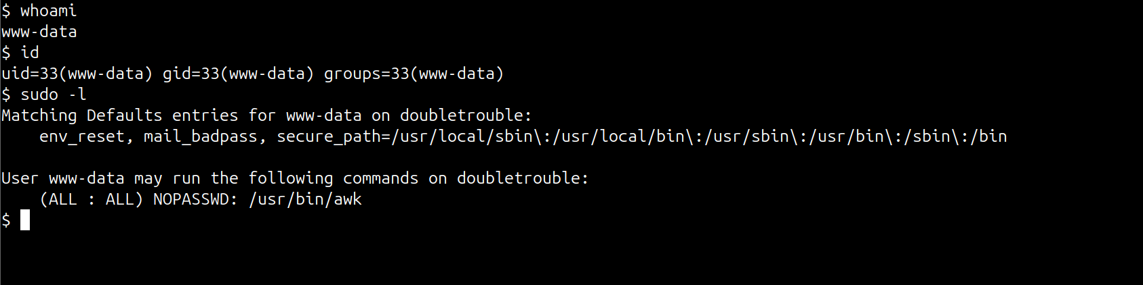  - Lets check on GTFOBins  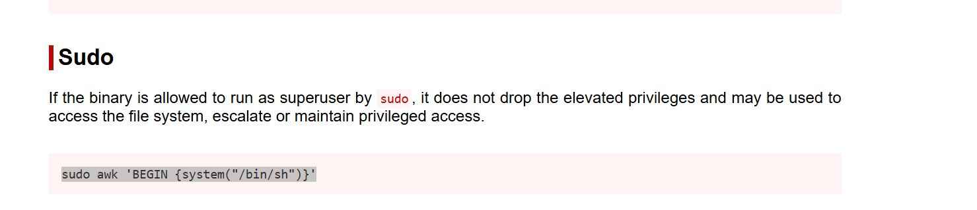  - Let’s try to run the command  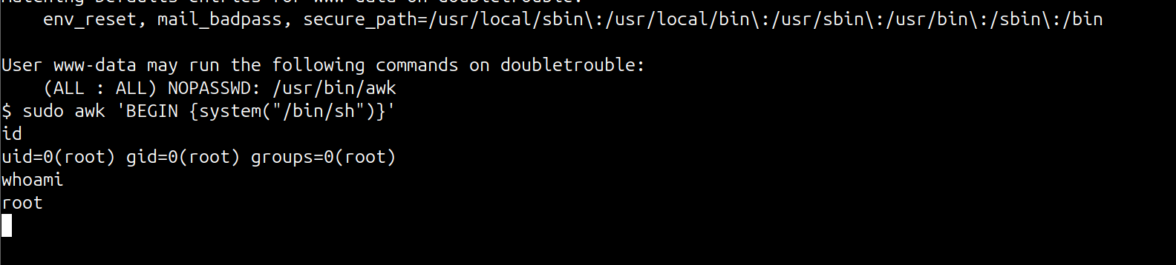  Got root access
Impact | • Attacker can run OS commands remotely through web input.  • Credentials retrieved from the second vulnerable app lead to user shell access.  • Misconfigured SUID binary provides direct root-level privilege escalation.  • Complete takeover of system, files, and application data.
Remediation | • Remove unsafe system calls and validate all parameters in web scripts.  • Disable directory listing, remove exposed credential files, enforce strong passwords.  • Audit and remove unnecessary SUID binaries, enforce least-privilege.  • Apply OS patching and restrict access to administrative pages via IP whitelisting.
Reference | https://nvd.nist.gov/vuln/detail/CVE-2014-6271  https://nvd.nist.gov/vuln/detail/CVE-2016-1247

